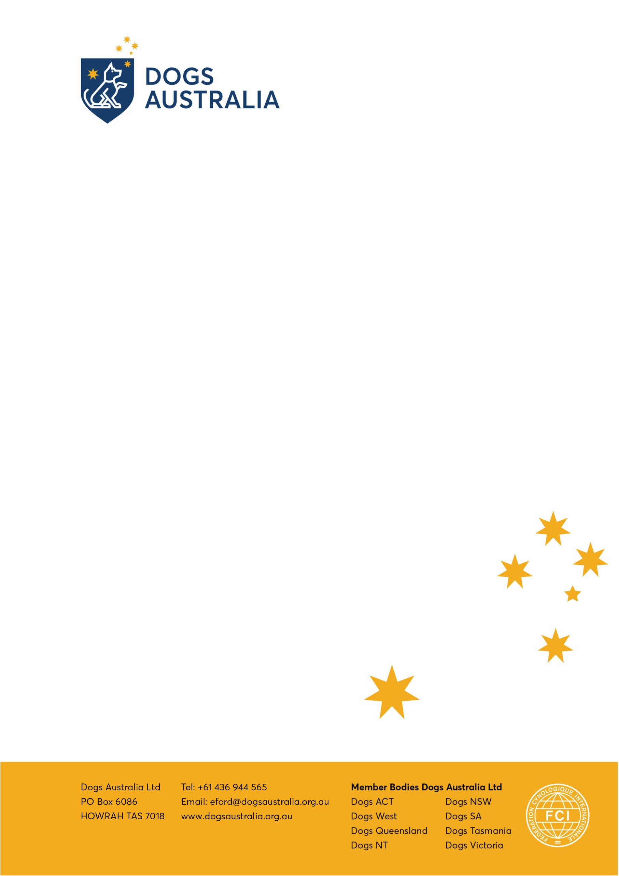

Australian National Kennel Council Limited ABN 77 151 544 679 trading as Dogs Australia

Application for FCI Judges Listing
Australian Judges Details

Date of birth (a mandatory requirement of FCI.
Name
State
Postcode
Mobile
Email
Languages Spoken
First Breed
Prefix
First Group
Year first group attained
Approved Groups

DA FCI Judges List Application.doc

